**JAVA LAB QUESTIONS 2024 BCA**

1. Write a Java program to find the area of a triangle and rectangle using method overloading.
2. Write a java program to perform the arithmetic operations using the concept of method overloading.

a) Get two integers as input and return float value as output.

b) Get two float value as input and return integer value as output.

1. Write a Java Program to print factorial of a given number. If the number is negative then throw a user defined exception.
2. Write a Java program to evaluate the expression x/(x-5) where x>5, if the value of x is less than or equal to 5 throw a user defined exception.
3. Create an abstract class called **Figure** which contains three data members ( length, breadth and height). Include an abstract method to find the **area** . **Figure** class also contains concrete methods to read the data members and to display them. Derive two classes **Rectangle** and **Triangle** from **Figure** and override **area()** to find the area of a rectangle and triangle.
4. Create an interface Shape and a child class Circle. Shape has member function calculateArea() and a constant data member pi(3.14). Write a java program to compute area.
5. Write a java program to find the details of the students eligible to enroll for the examination (Students, Department combinedly give the eligibility criteria for the

enrollement class) using interfaces.

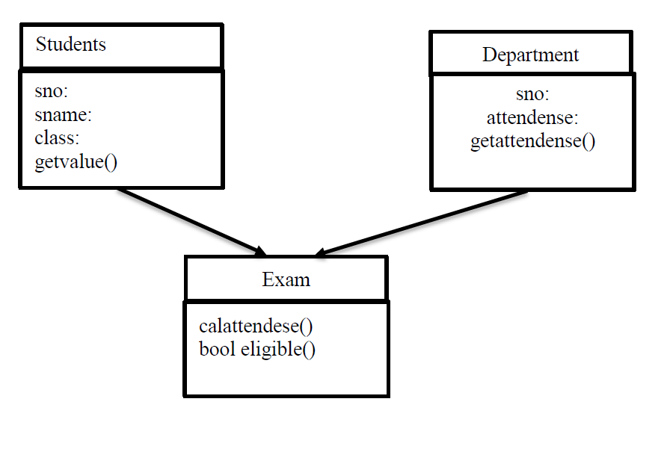

1. Write a Java program to create a class Complex for reading and displaying a complex number under a user defined package comp.
2. Write a Java Program to create a class Factorial for computing factorial of number using a user defined package fact.
3. Write a Java program to implement two threads, one for printing odd numbers and another for even numbers simultaneously.
4. Write a Java program to implement two threads one for printing prime numbers and the other for printing even numbers simultaneously.

12. Demonstrate stack using interface

13.Write a package program to check whether a number is prime. Import the package to check whether a number is prime and if the number is prime, check the digits are also prime.

14.Write a Program to implement all string handling functions.(length, concatenation, character extraction, string comparison, string index, substring, replace, lower and uppercase, trim)

15.Write a program to sort strings in alphabetical order.

16. Write a program using swing to accept values in two textboxes then find the largest number and display the result in third text box.

17.Write a java application program to print odd and even numbers less than 100 using multithreading.

18.Write a swing program to accept a value in a textbox then find the area of a circle and display the result in the second textbox? (hint : A = πr2 )

19.Create an interface “CreditCardInterface” with methods to viewCreditAmount, viewPin, changePin, useCard and payBalance. Create a class Customer (name, card number, pin, creditAmount – initialized to 0). Implement methods viewCreditAmount, viewPin, changePin and payBalance of the interface. From Customer, create classes RegularCardHolder (maxCreditLimit) and GoldCardHolder (String specialPrivileges) and define the remaining methods of the interface.

20. Create an abstract class called Figure which contains three data members ( length, breadth and height). Include an abstract method to find the area .Figure class also contains concrete methods to read the data members and to display them. Derive two classes Rectangle and Triangle from Figure and override area() to find the area of a rectangle and triangle.

21.Define class MyDate with members day, month, year. Define default and parameterized constructors. Accept values from the command line and create a date object. Throw user defined exceptions – “InvalidDayException” or “InvalidMonthException” if the day and month are invalid. If the date is valid, display message “Valid date

22.Write a swing program to accept an integer in a textbox then reverse that number and display the result in the second textbox?

23.Write an applet program to draw a Kite?

24.Write an Applet program to draw a rectangle and a circle by passing parameters to Applet.

25.Write an Applet program to draw a pie-chart, x={2010, 2011,2012}, y={90,80, 95}.

26.Write a Java GUI program to implement simple interest calculator(I=P*N*R)

27.Write an Applet program to draw the following shape



28.Write an applet to draw the following shape of a circle using the above relationship.



29.Write an applet to create national flag.

30.Define a class Account and subclasses FD and SB. Write menu driven program to perform operations deposit, withdrawal and display details. Repeat the operationsbased on user option.

31.Create a mysql table employee(empno varchar(10) primary key, ename varchar(10),department varchar(10)) and insert five records. Write a java program to display the employee’s records in the order of department name.

32.Create a mysql table mark(regno int primary key, sname varchar(10),mark int) and insert five records. Write a Java program to read and display the content of mark table.

33.Write a java program to animate a traffic light.

34.Write a java program to implement a simple Calculator.

35.Write a program using swings to accept values in two textboxes and display the results of mathematical operations in third text box. Use four buttons add,subtract,multiply and divide.